**Genii Analytics | Audit Function | AQA**

Contents

Scope 2

Starting off 2

Delete 7

EnableEdit 8

Other Audit Functions 11

Validated 11

Review 12

ScoringAudit 13

# Scope

This feature was created to allow for captures to be amended/edited or deleted by the user.

You may want to delete an assessment if your target per day/agent/month has been exceeded.

You may need to update an assessment where some information has been incorrectly captured, like the agent or team leader or if the incorrect causal factor where selected or not selected.

Notation: You cannot amend/edit a connection id or call date. If these inputs need to be changed you will have to delete the assessment and recapture it.

# Starting off

Your best way to access the assessment you wish to change is via the Overview page.

There are other ways to get to the assessment, but this is the easiest.

Once you have logged in, go to Management -> Campaigns Management

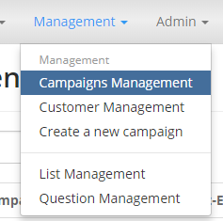

You can access the Overview page of the campaign by clicking on any of the following hyperlinks: ID, Description or Overview.

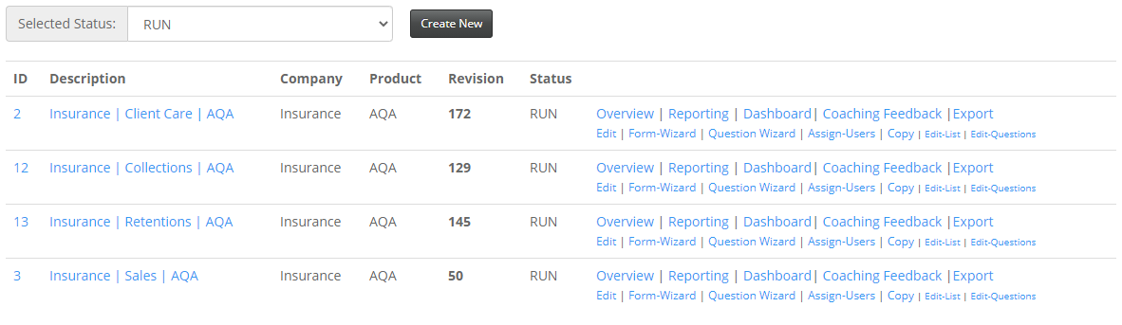

This will take you to the Overview of Campaign page.

Check that your connection id falls within the campaign dates in the breadcrumb below.

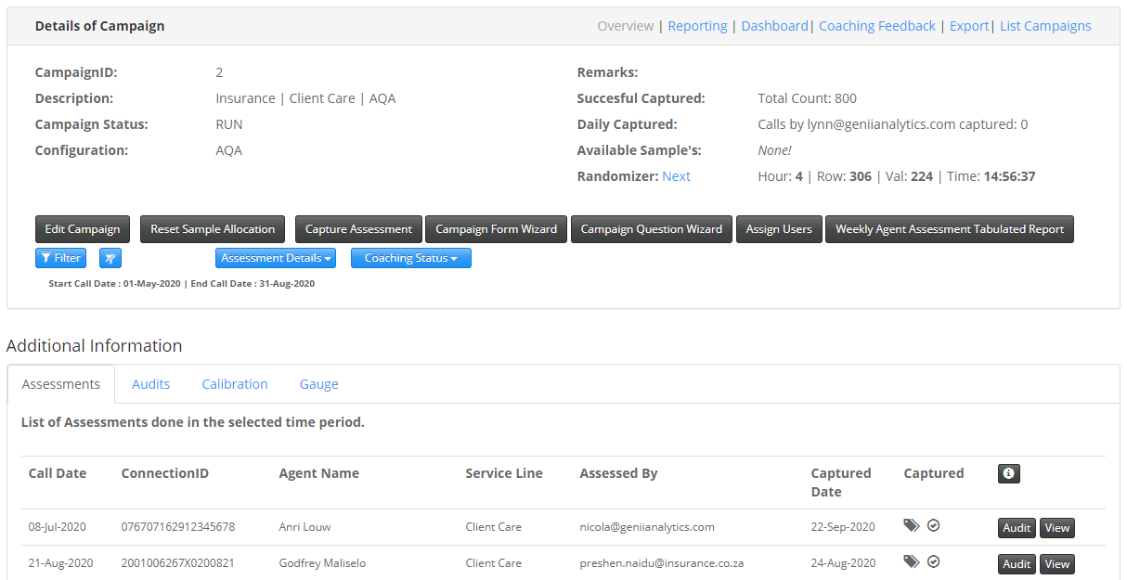

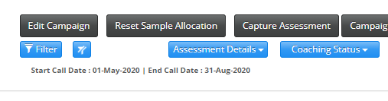

You can use the filter to search for a specific id or use the date filter if you are going to delete to stay within target.

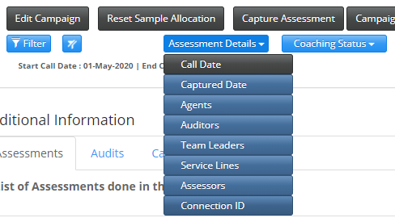

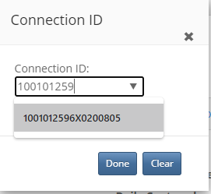

Once you have isolated the id you wish to change, you need to click on the Audit button next to the Connection Id.

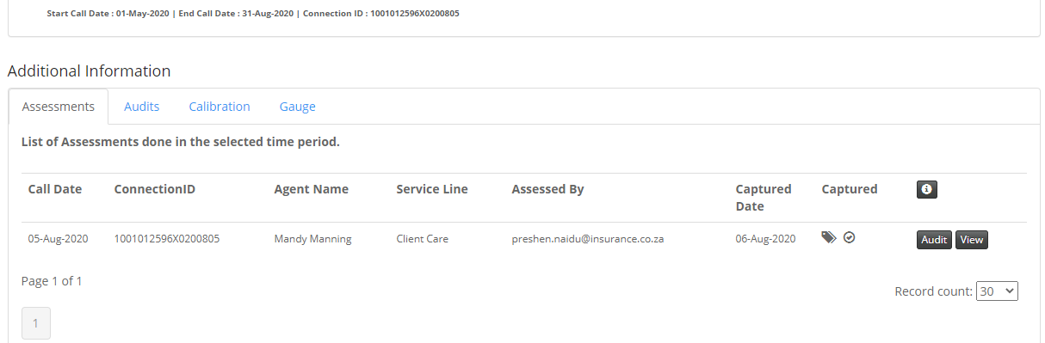

This will take you to the audit page – view below.

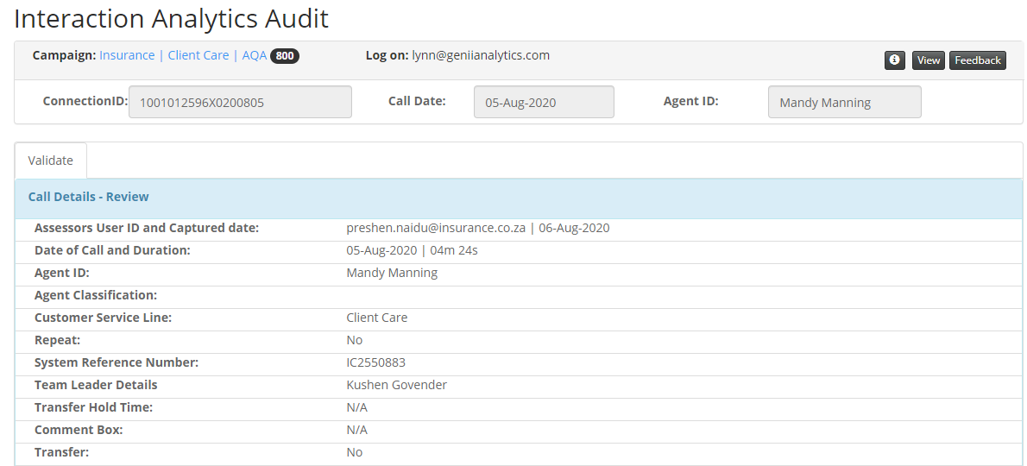

Scroll down to the bottom of the page and select the Auditing Tab

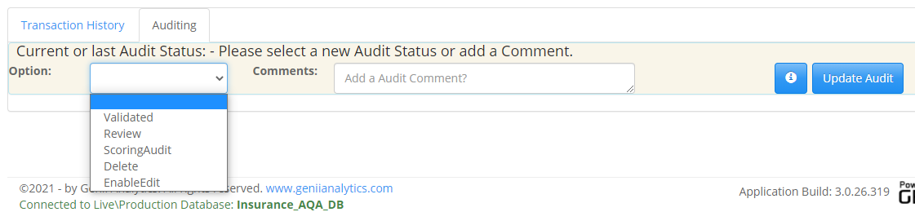

By engaging the drop-down you can see the options available.

There are 5 options in this selection box: Validated, Review, ScoringAudit, Delete and EnableEdit

* Validated: Confirmation by the auditor that the assessment has been done correctly.
* Review: This is the auditor’s instruction to the assessor to review said work and rectify.
* Scoring Audit: To be announced
* Delete: Completely removing the assessment and allowing for recapture of the connection id if required.
* Enable Edit: updating an assessment with additional data or correcting previously made choices.

Whichever option you select should be accompanied by a brief explanatory comment in the available comment box.

For the purposes of this document, we will be focussing on the EnableEdit and Delete functions.

# Delete

Why delete an assessment?

1. The assessment was completed wrong (incorrect call, incorrect campaign, over sample size, etc)
2. The Call Date or Connection ID was not captured correctly. (These are the only fields that cannot be updated with EnableEdit function). The assessment will then have to be recaptured with the correct detail.



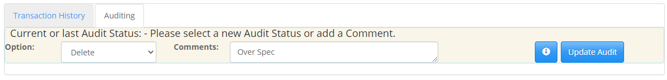

Select Delete from the drop-down and add your comments and select Update Audit.

Once you have selected Update Audit you will be taken to the Interaction Analytics Audit page which will display confirmation of your actions.

See Below

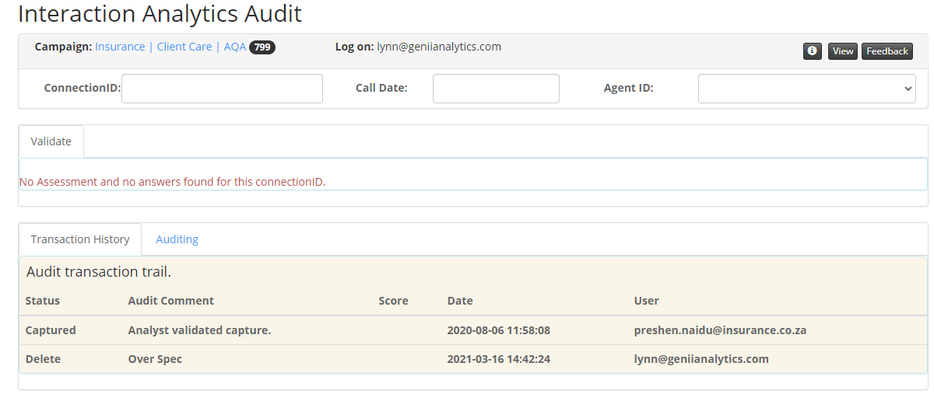

EnableEdit

Why EnableEdit?

1. Update the body of the assessment, except for, the call date or connection id.

This includes updating causal factors or metadata on the call details page.



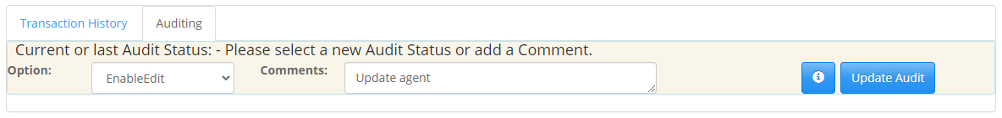

Select EnableEdit from the drop-down and add detailed comments (preferably what you are changing and why).

You will see the following on the top of the page, confirming your selection.

Select View to move forward.



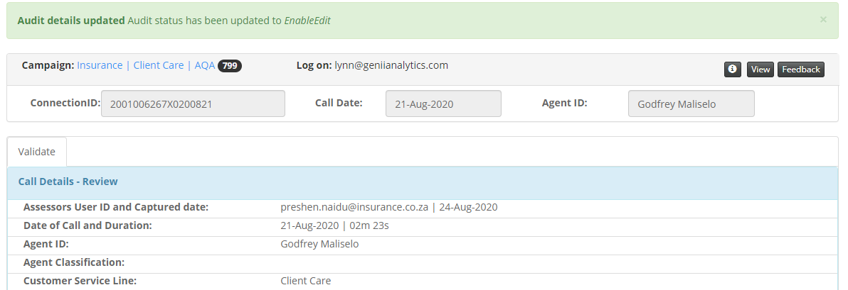

This will take you to the Analytical Quality Assurance page.

From here you can make the changes required, before Validating and Submitting the updated assessment.

For this exercise we will updated the agent id from Godfrey to Yaseen.

Note the blue notification bar advising that you can edit this assessment.

Before

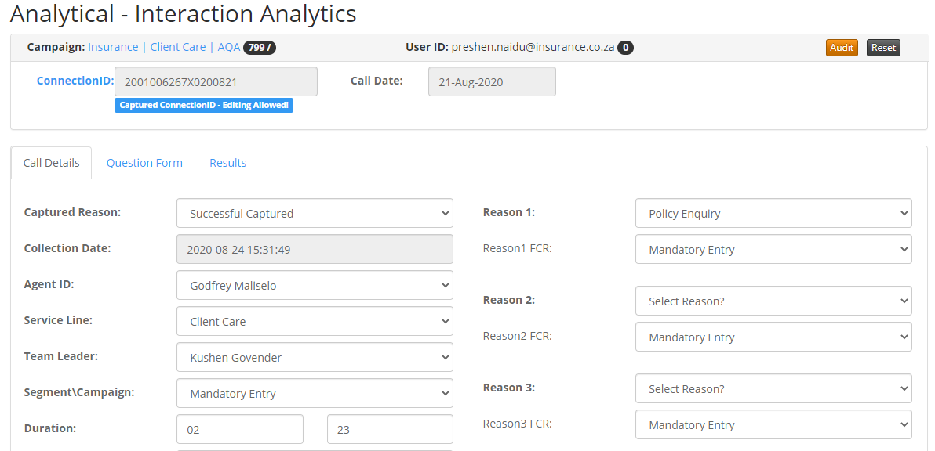

After

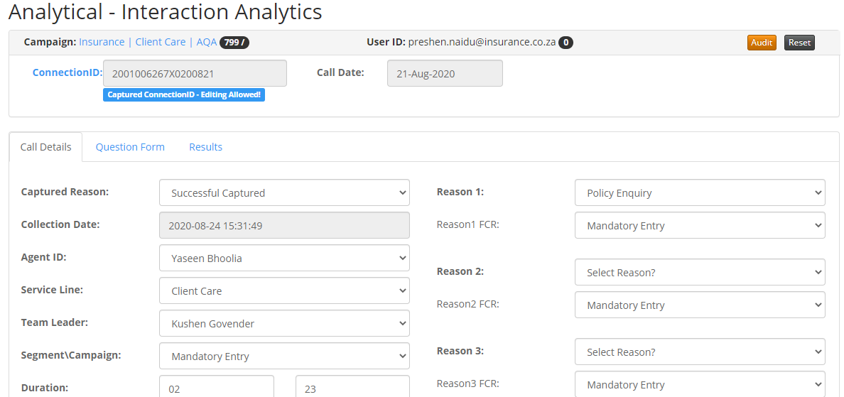

Once you have validated and submitted, you will be taken to a new assessment page with a confirmation of your update on the top of the page. (Blue notification bar on top of page)

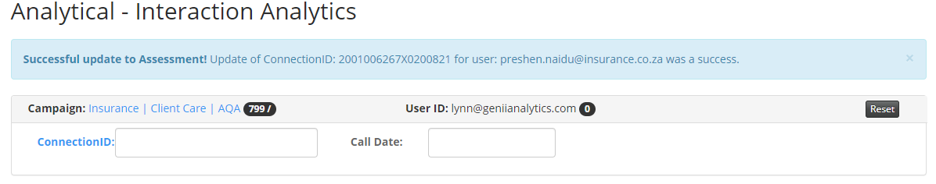

On the Overview page you can now see that the Agent Name has shows the updated agent name.

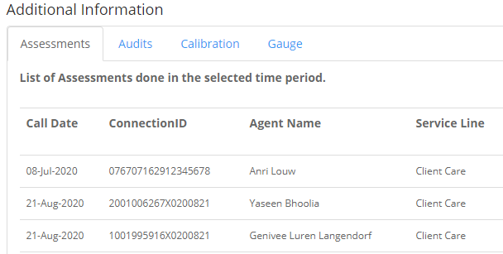

Other Audit Functions

The only documentation linked to these actions are on the Audit Export.

Review and Scoring Audit has been replaced with [Calibration](Calibration%20Feature%20-%20Genii%20App.pdf)

## Validated

1. Random testing where the assessment was done correctly.

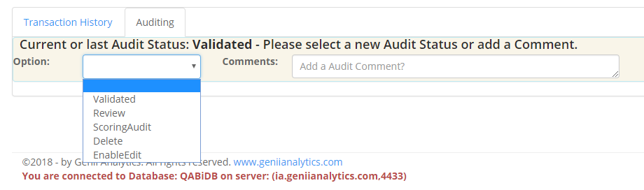

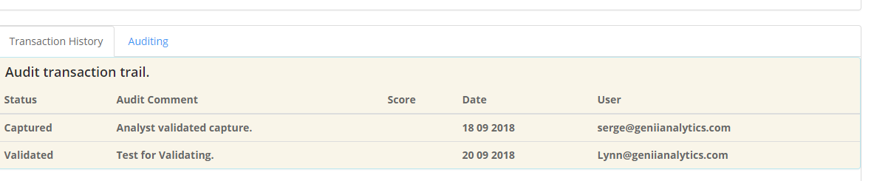

## Review

1. Random testing where the assessment was done incorrectly.

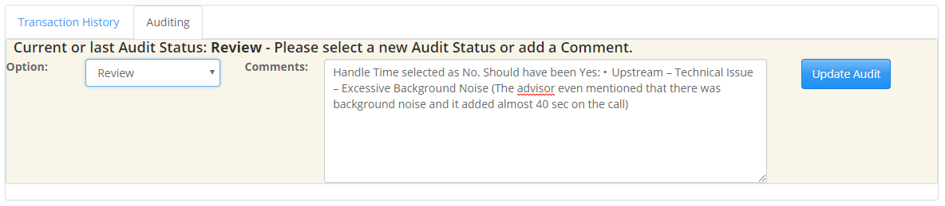

This allows the assessor to add a comment to the review.

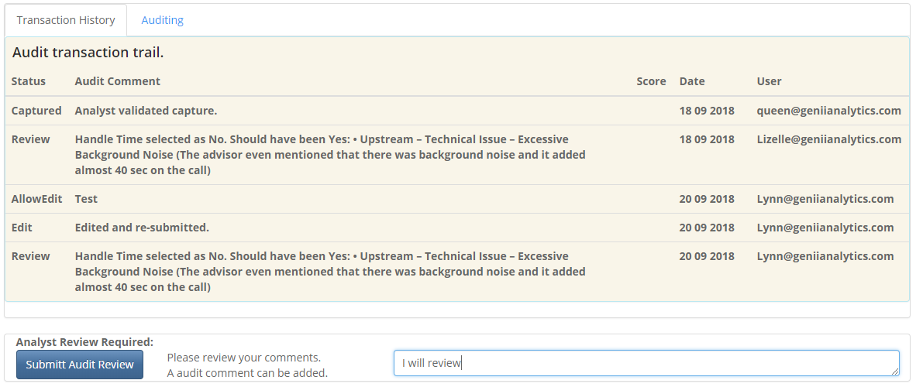

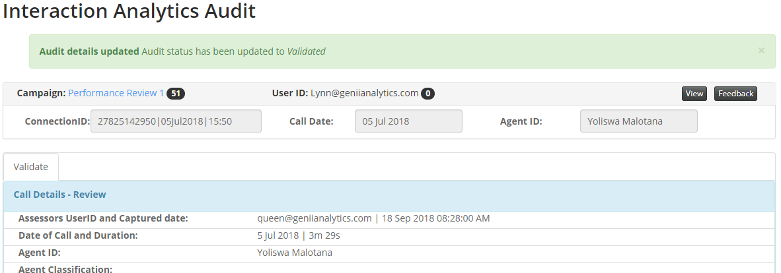

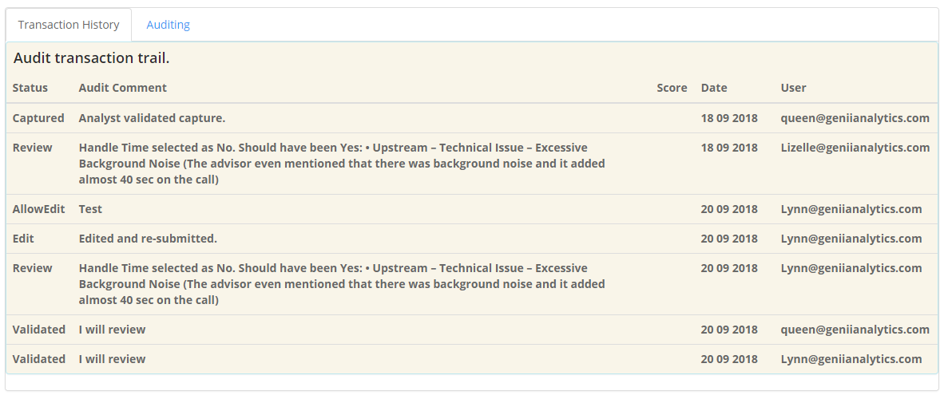

## ScoringAudit

1. Random testing where an assessment was done, and a pass/fail flag can be attached.

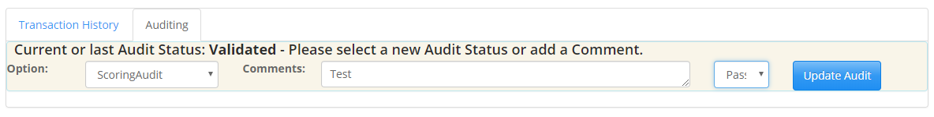

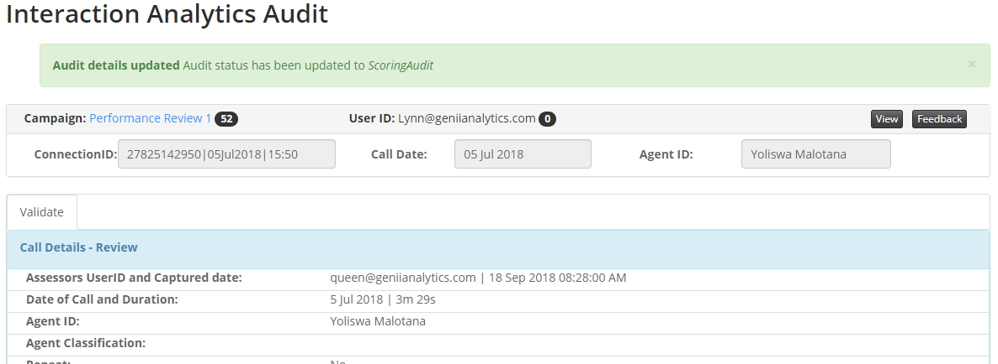

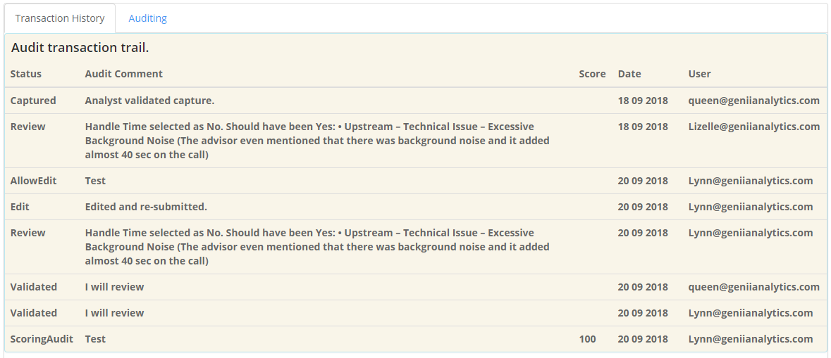

FIN